PROJECT REPORT TEMPLATE

1.Introduction

1.1 Overview

Let us see about the project undertaken by my team that is “Property Management Application Using Salesforce”.

In this project we have to develop an App for the Property Management where Buyer can order his Requirements and get the Appropriate Details of the Property. According to his interest just provide him with some discounts upto what extent he can get the discount. Also Track Whether he is Interested in taking the loan available for so just calculate how much loan Amount user can get it. Provide the Security for two different profiles like for marketing and sales team. Then Finally Create the reports and dashboard so there will be clear view just get the reports on the count of loan passed getting the property purchased close the deal.

1.2 Purpose

In this project “Property Management Application Using Salesforce” we had learned the main two objectives. They are mentioned below,

1. Real time salesforce project.
2. Object and relationship in salesforce

2.Problem definition and design thinking

* 1. Empathy map

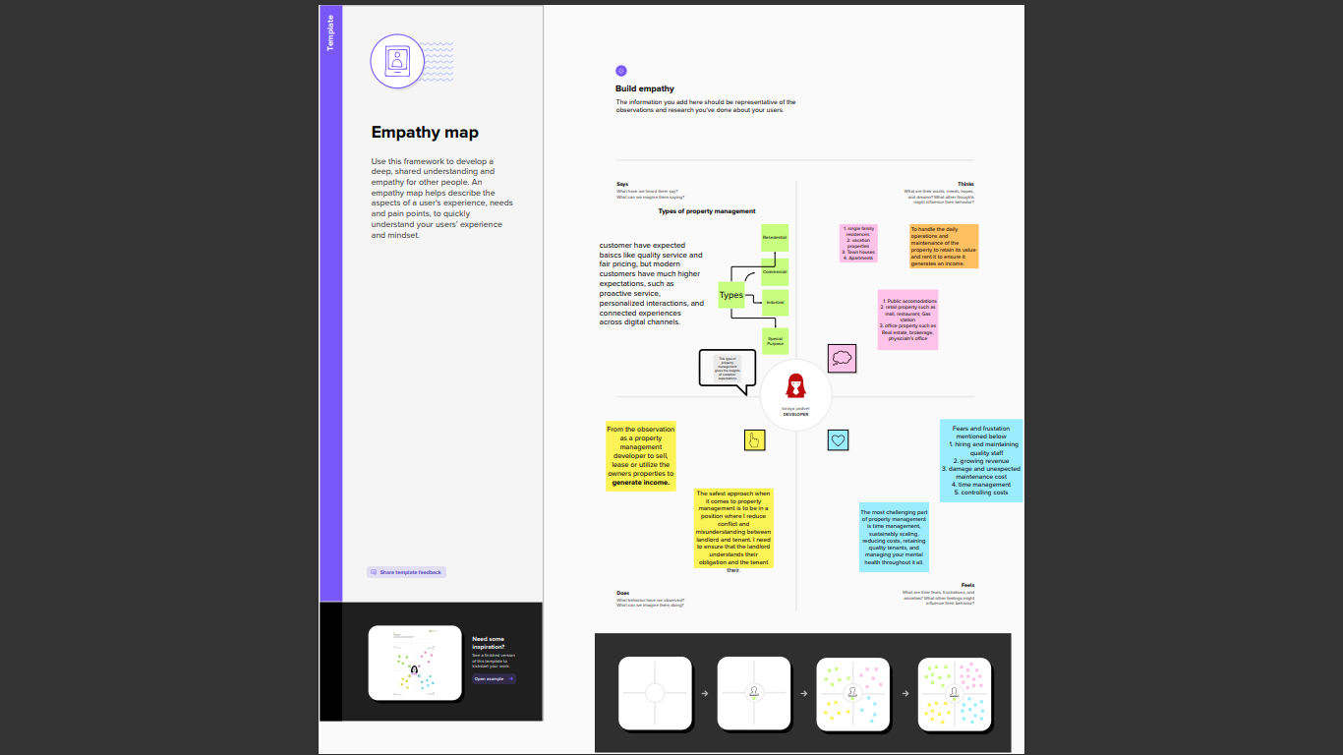

2.2 Ideation and Brainstorming map

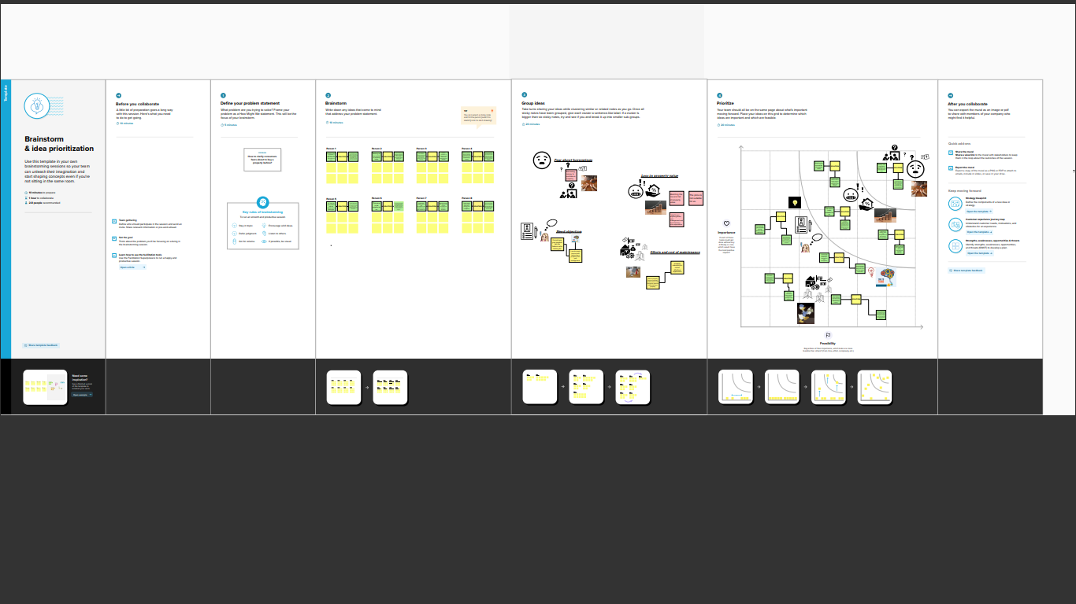

3.Result

3.1 Data model

|  |  |  |
| --- | --- | --- |
| Object Name | Fields in the object | |
| 1. Standard Object | Field Label | Data type |
| 1. Account Name | Name |
| 1. Custom Object | Field label | Data type |
| 1. Lead | Auto number |
| 1. Buy | Text (80) |
| 1. Rent | Picklist |
| 1. Loan | Number (18,0) |

3.2 Activity & Screenshot

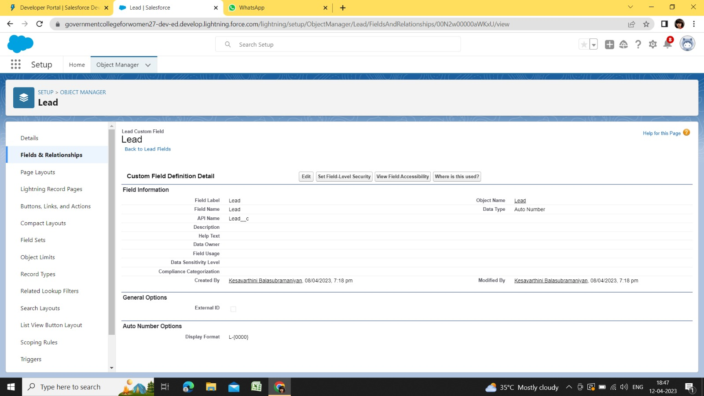

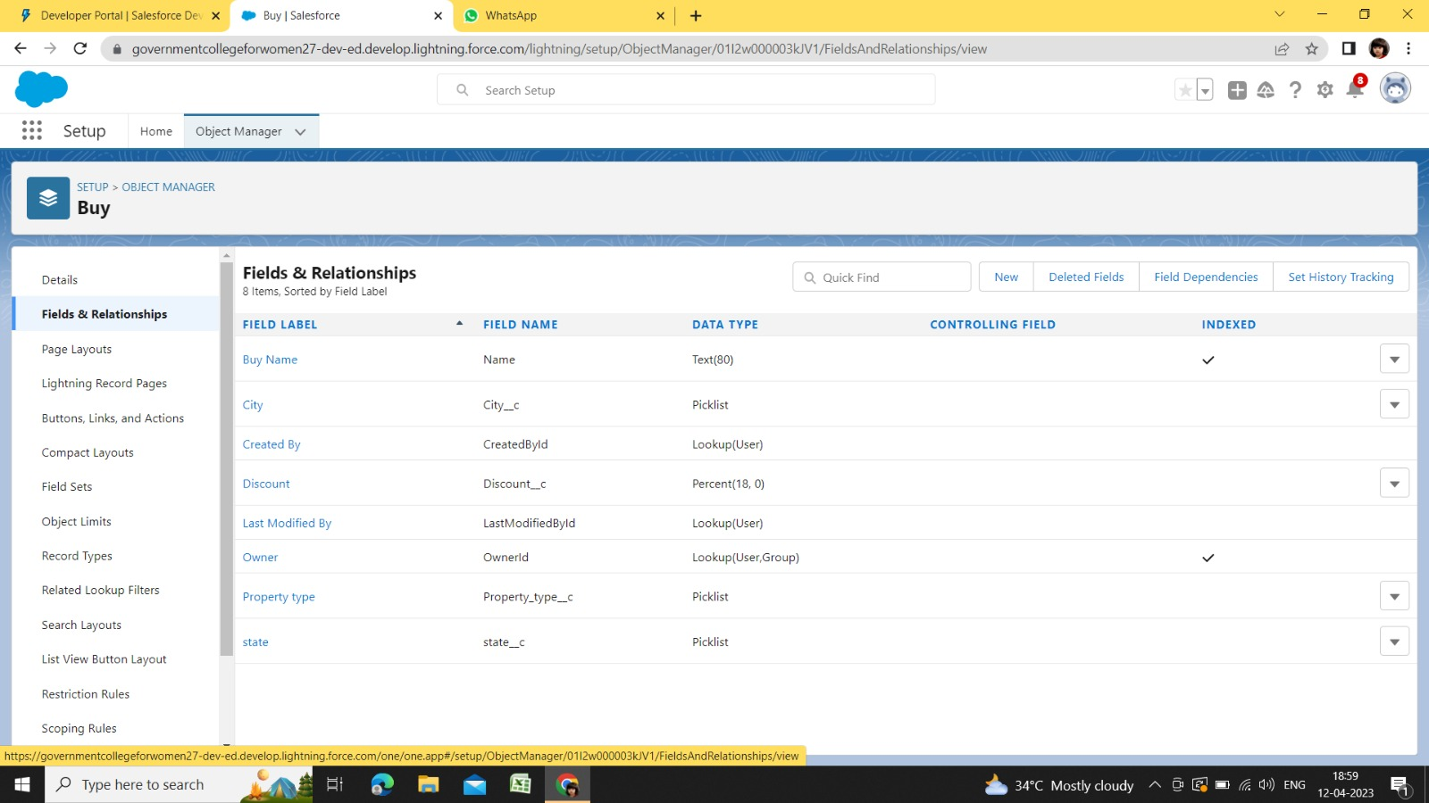

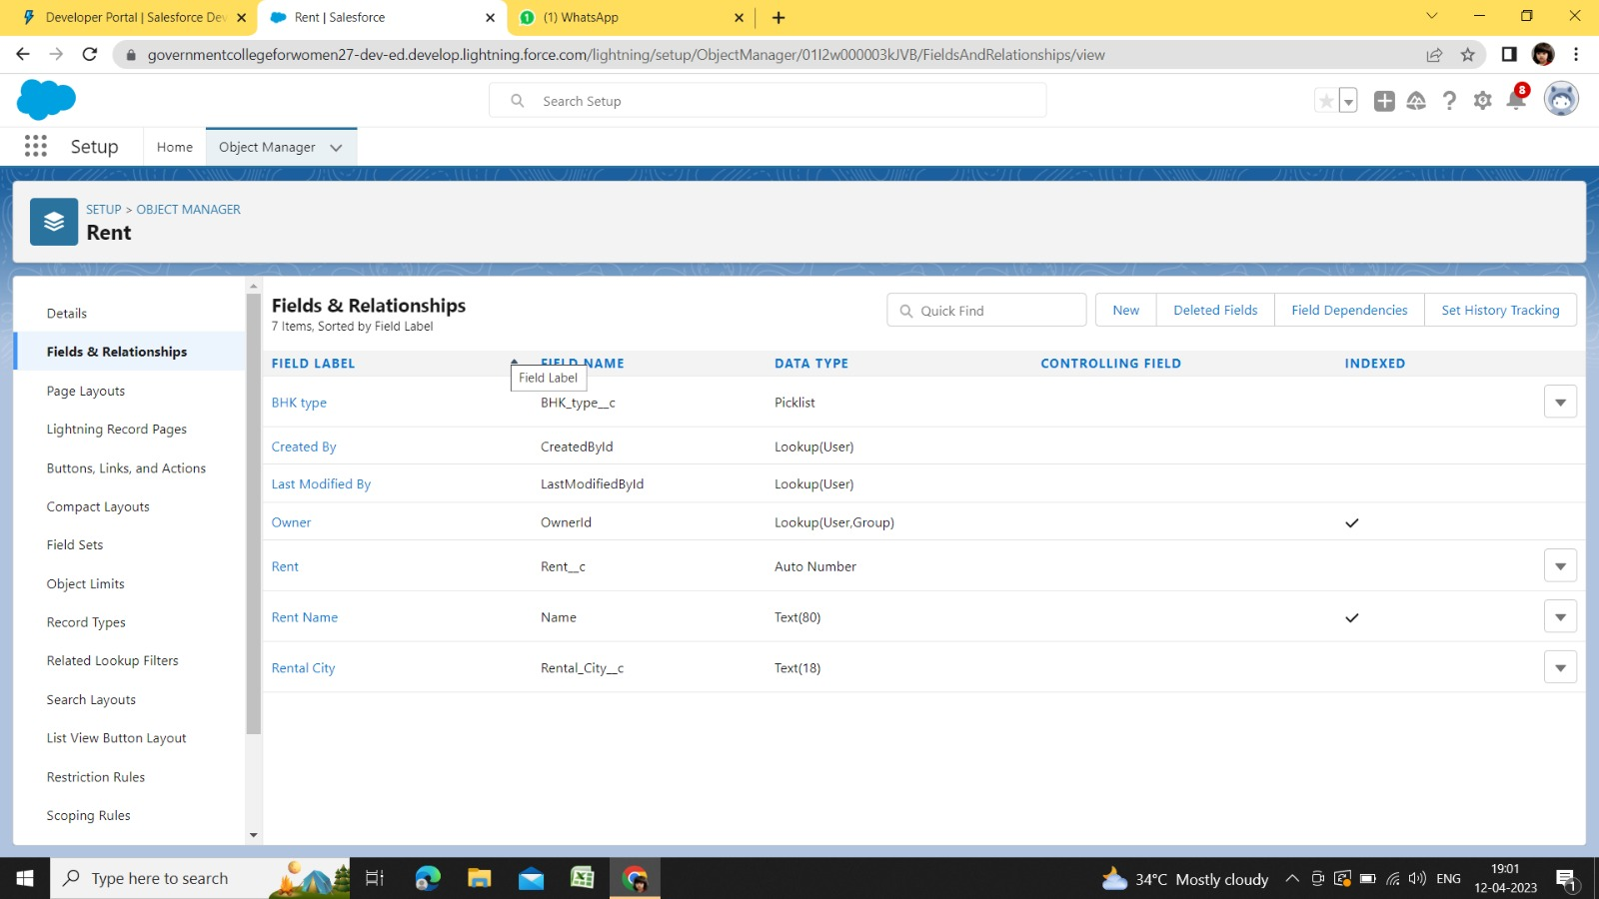

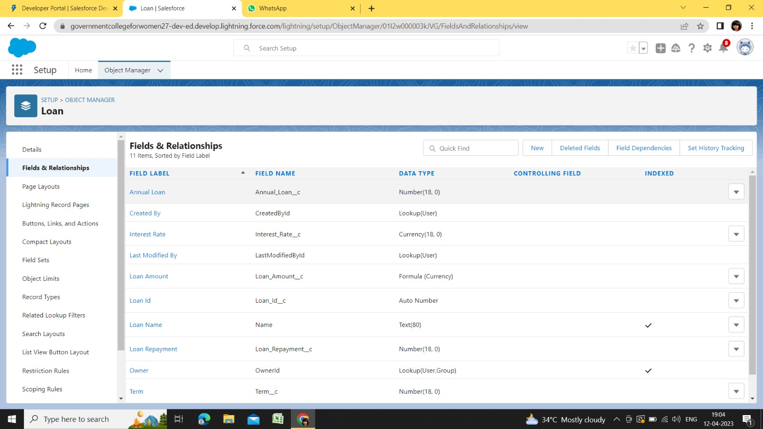

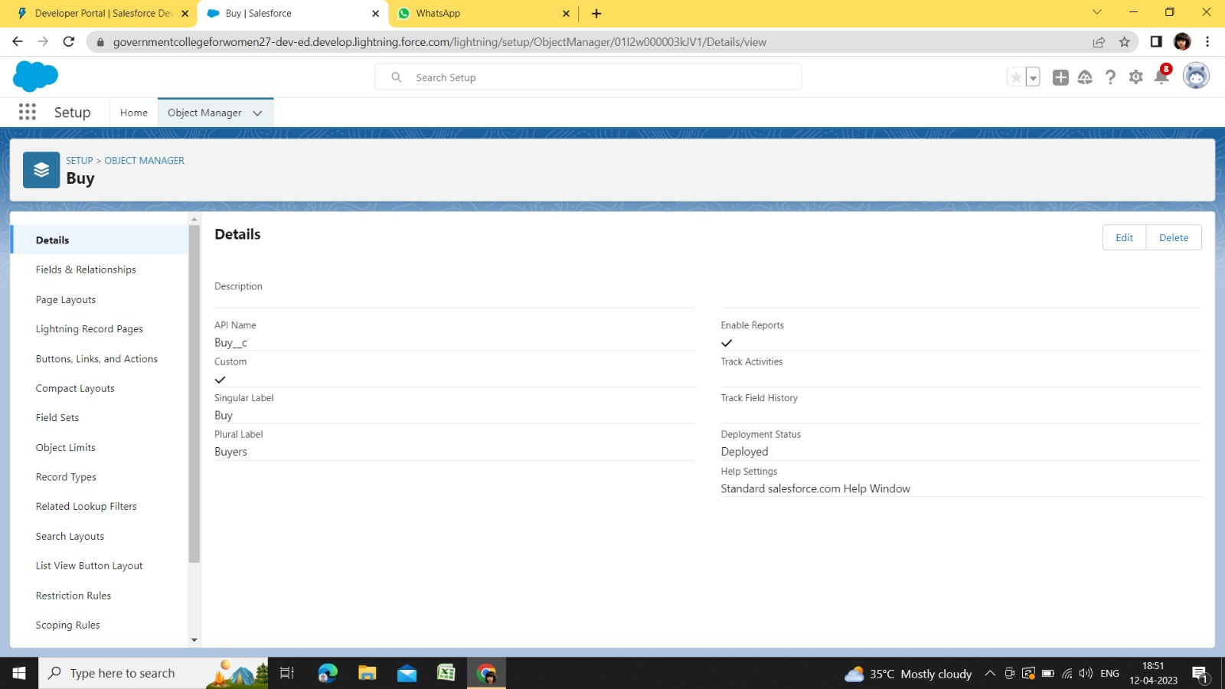

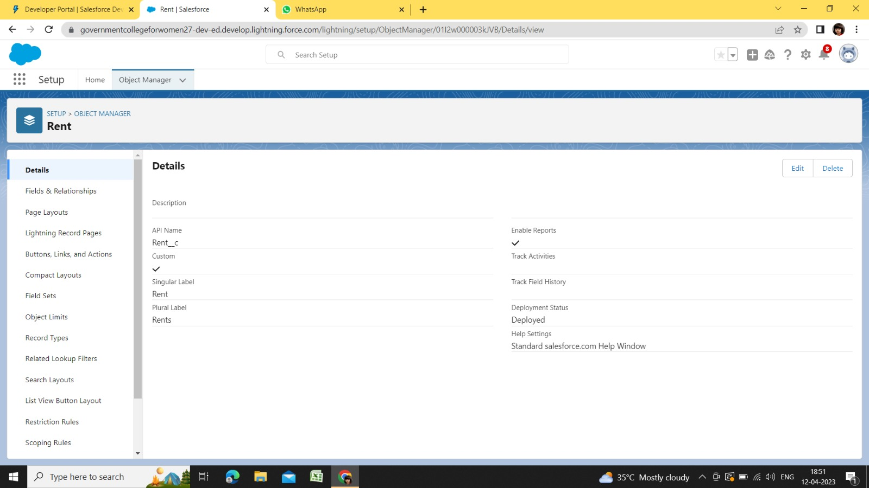

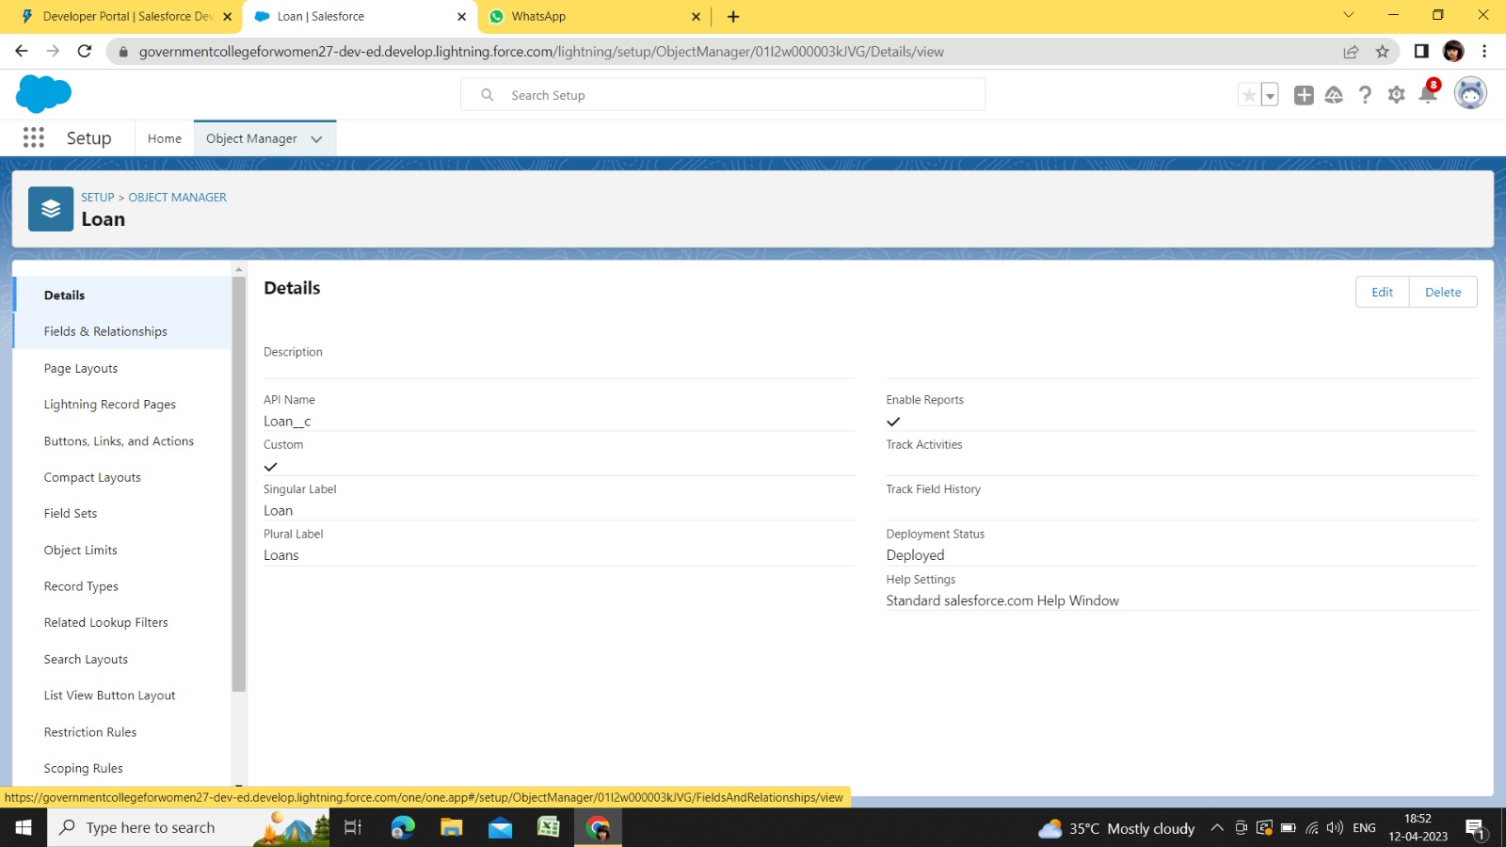

4.Trailhead Profile Public URL

1. Team Lead – <https://trailblazer.me/id/kvadivel3>

2. Team Member 1 – <https://trailblazer.me/id/kbalasubramaniyan3>

3. Team Member 2 – <https://trailblazer.me/id/ttskiruthika>

4. Team Member 3 – <https://trailblazer.me/id/lraja61>

5. Team Memeber 4 – <https://trailblazer.me/id/abaranitharan1>

5.Advantages & Disadvantages

5.1 Advantages

Advanced technologies change the way property managers’ deal with different property-related management tasks. The most important advantages are mentioned below;  
  
 • Trust accounting  
  
 • Maintenance

• Inspection  
  
 • Communication  
  
 • Reporting  
  
 • Designing organizational changes.  
  
 Workflow management is a very versatile term and this software allows automated processing of rental applications, tenant screening, property inspection-related operations, lease operations and management of invoices, approvals management, preparing financial reports and other forms and documents.

5.2 Disadvantages

Disadvantages of property management software installation result from the inadequate use or picking the wrong system for your business. Those include:  
  
 • Time-consuming if you choose the wrong system. Make sure you analyze your own business, the scope of the projects you lead and work on and decide on the type of the property management system which will suit you the best. If you are running a small business, choosing a simple, user-friendly interface PMS is the best option.  
  
 • Might seem expensive for a small business. However, the system will pay off within less than a year as it will literally start making money for you. The investment is worth the expense in the long run.  
  
 • Training (cost and time). This depends on the readiness of your staff to learn. However, the software is user-friendly and everyone should be able to learn how to use it within a week.

6.Applications

A property management is a software application for the operations of hospitality accommodations and commercial residential rental properties.  Property management is also used in manufacturing industries, local government and manufacturing.  
  
 Property management provides a centralized computer system to organize, schedule and perform the day-to-day functions and transactions involved in accommodations businesses. Computer record keeping and  property management have increased the efficiency of hospitality industries significantly simply by making it possible to update and consult centralized records from multiple computers and devices.  Property management solutions have been customized for the needs of the hospitality industry to further increase ease of operations.

7.Conclusion

1. Learn to build a real-time application using Salesforce out-of-the-box features, apex and visualforce.  
 2. Learn to integrate Salesforce with third party service.

3. Learn Apex programming with hands on project.

4. Learn about Custom Settings and different types of custom settings in Salesforce.  
 5. Learn about Remote Site Settings and its use.

8.Future Scope

The following demands may enhance in future.

Executing long-running operations such as external web services or any operation you would like to run in Its own thread on its own time.